Test Case: tc001_SPX_Dev5_Crear_Requisicion_Spot_Tipo_Cobro_CC
Step 1 - Enter username and password and click to button Enter : Credentials Entered
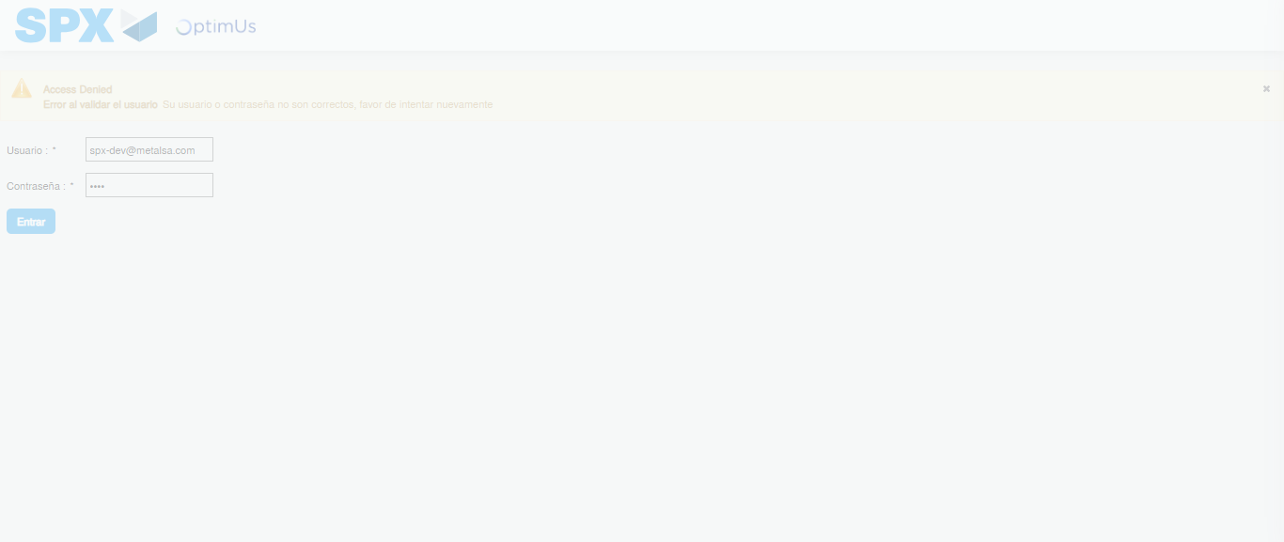Image file-name: QC_Testing-tc001_SPX_Dev5_Crear_Requisicion_Spot_Tipo_Cobro_CC-1783978811854

Step 2 - Select to UEN and Access to Spot Buy Requisitions : UEN Correctly selected and Correct access
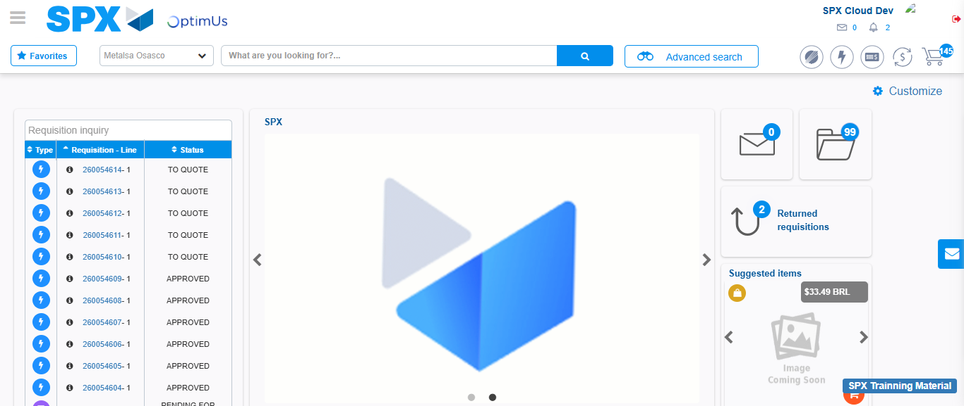Image file-name: QC_Testing-tc001_SPX_Dev5_Crear_Requisicion_Spot_Tipo_Cobro_CC-1783978881774

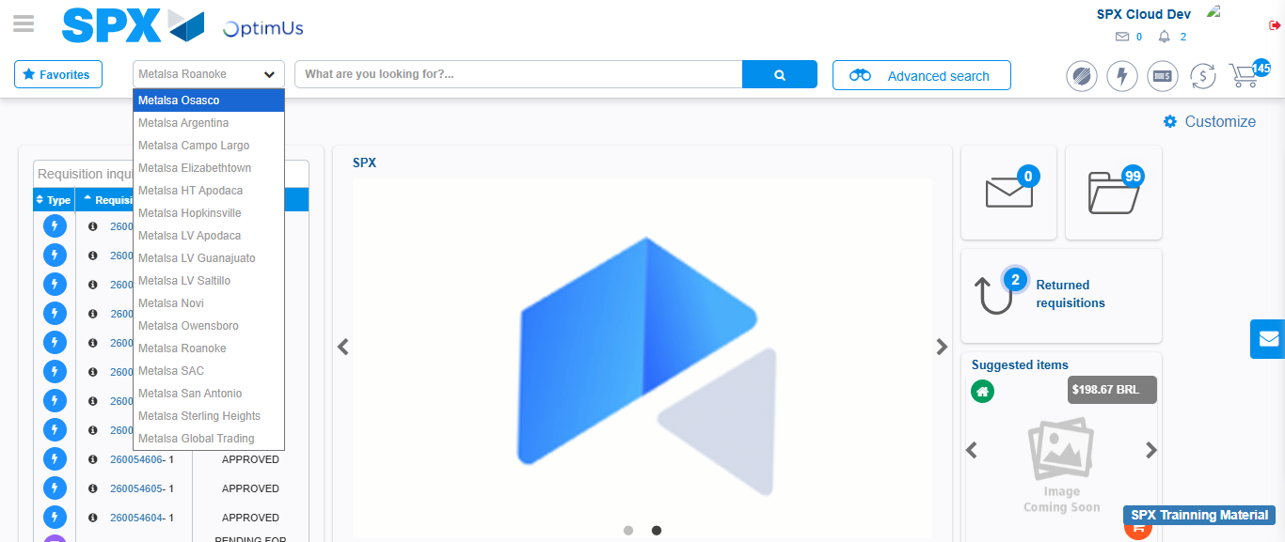Image file-name: QC_Testing-tc001_SPX_Dev5_Crear_Requisicion_Spot_Tipo_Cobro_CC-1783978884334

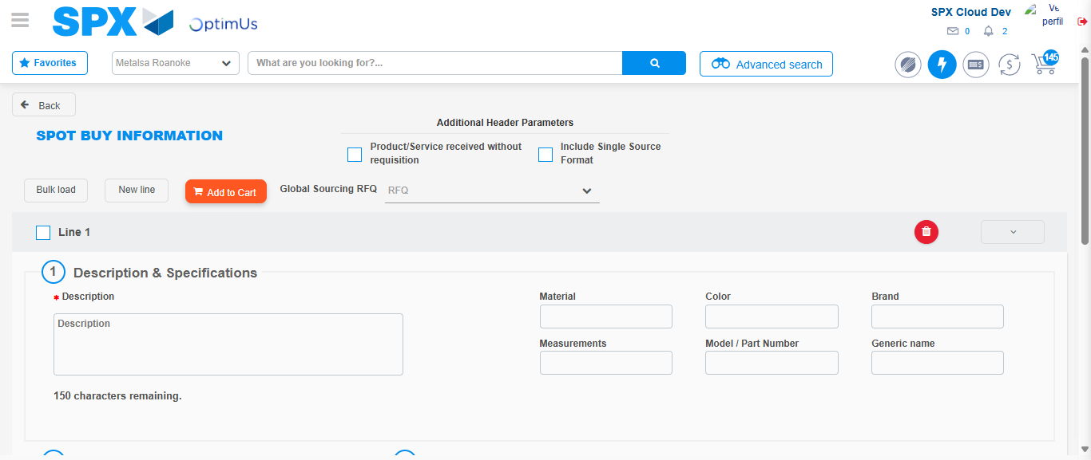Image file-name: QC_Testing-tc001_SPX_Dev5_Crear_Requisicion_Spot_Tipo_Cobro_CC-1783978890902

Step 3 - Data Capture Spot Buy Requisition : Data captured correctly
Image file-name: QC_Testing-tc001_SPX_Dev5_Crear_Requisicion_Spot_Tipo_Cobro_CC-1783978891148

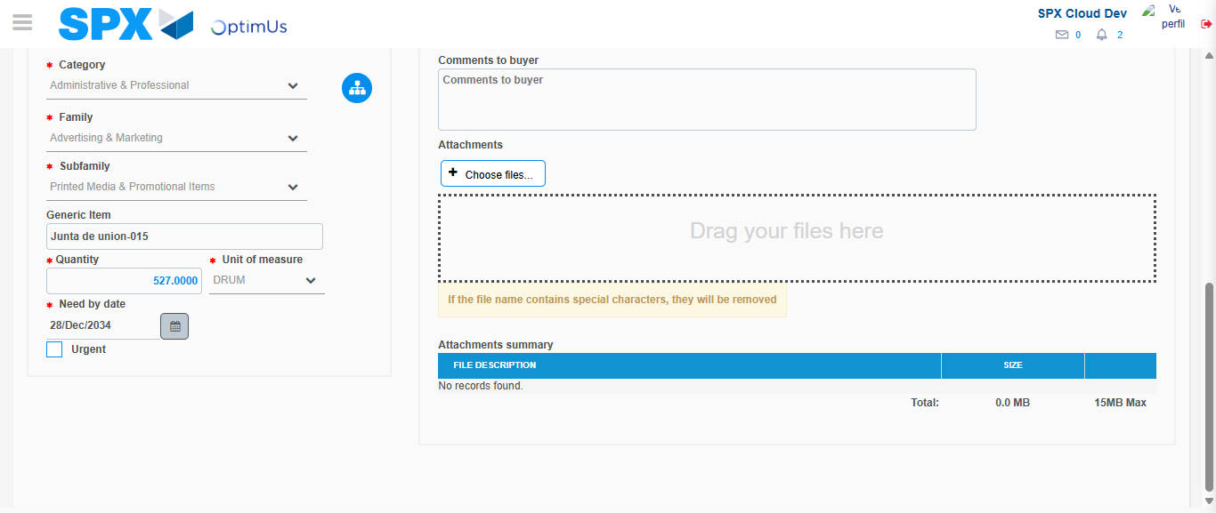Image file-name: QC_Testing-tc001_SPX_Dev5_Crear_Requisicion_Spot_Tipo_Cobro_CC-1783978900864

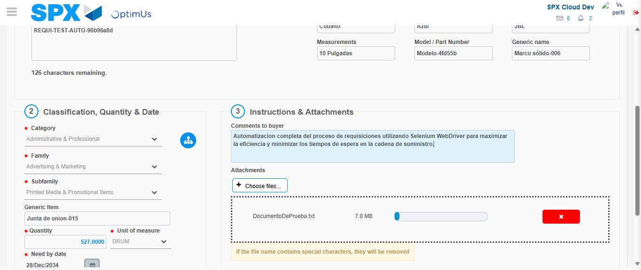Image file-name: QC_Testing-tc001_SPX_Dev5_Crear_Requisicion_Spot_Tipo_Cobro_CC-1783978901598

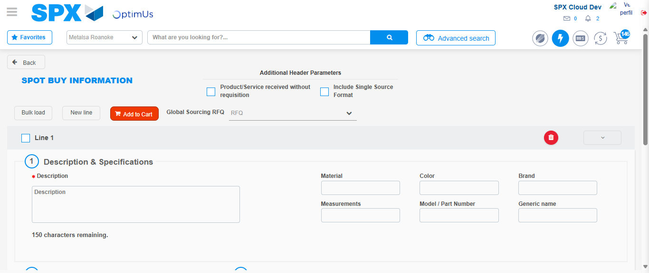Image file-name: QC_Testing-tc001_SPX_Dev5_Crear_Requisicion_Spot_Tipo_Cobro_CC-1783978914155

Step 7 - Return to Main Page SPX : Return to Main Page SPX
Image file-name: QC_Testing-tc001_SPX_Dev5_Crear_Requisicion_Spot_Tipo_Cobro_CC-1783978881774

Image file-name: QC_Testing-tc001_SPX_Dev5_Crear_Requisicion_Spot_Tipo_Cobro_CC-1783978884334

Image file-name: QC_Testing-tc001_SPX_Dev5_Crear_Requisicion_Spot_Tipo_Cobro_CC-1783978890902

Image file-name: QC_Testing-tc001_SPX_Dev5_Crear_Requisicion_Spot_Tipo_Cobro_CC-1783978916390

Image file-name: QC_Testing-tc001_SPX_Dev5_Crear_Requisicion_Spot_Tipo_Cobro_CC-1783978916557

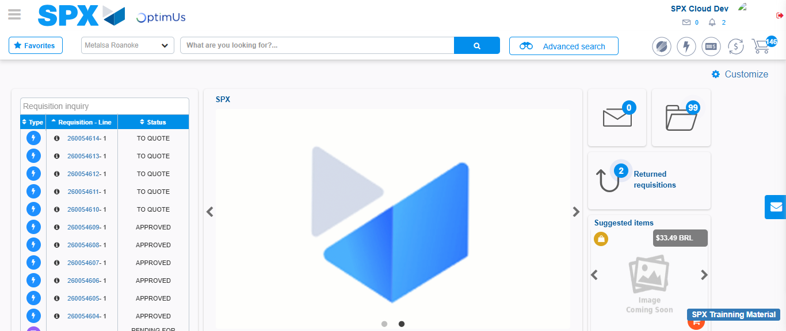Image file-name: QC_Testing-tc001_SPX_Dev5_Crear_Requisicion_Spot_Tipo_Cobro_CC-1783978937588

Step 8 - Log Out : Log Out SPX
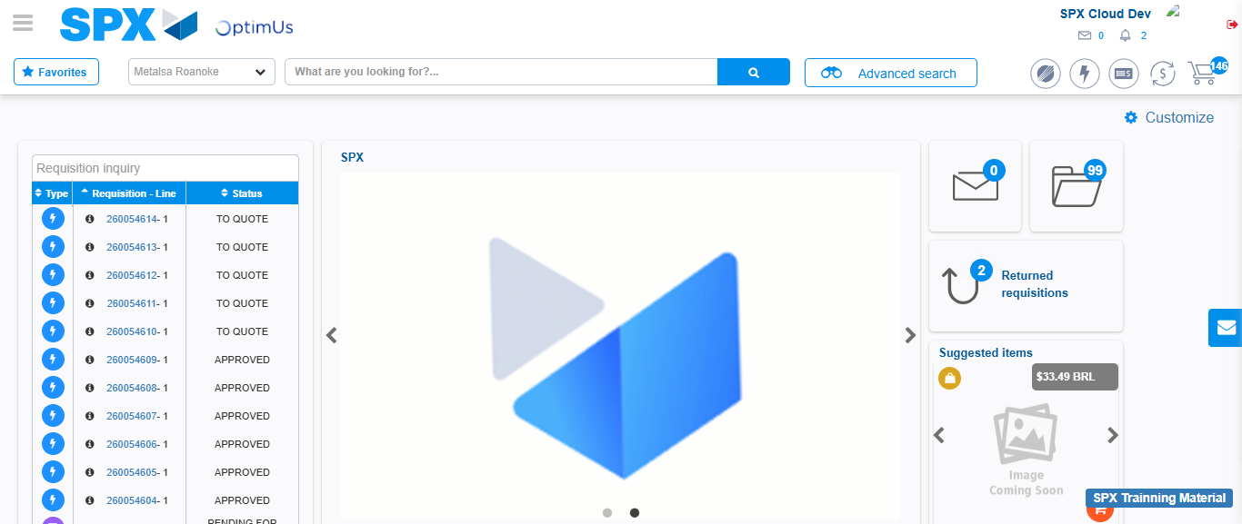Image file-name: QC_Testing-tc001_SPX_Dev5_Crear_Requisicion_Spot_Tipo_Cobro_CC-1783978937851

